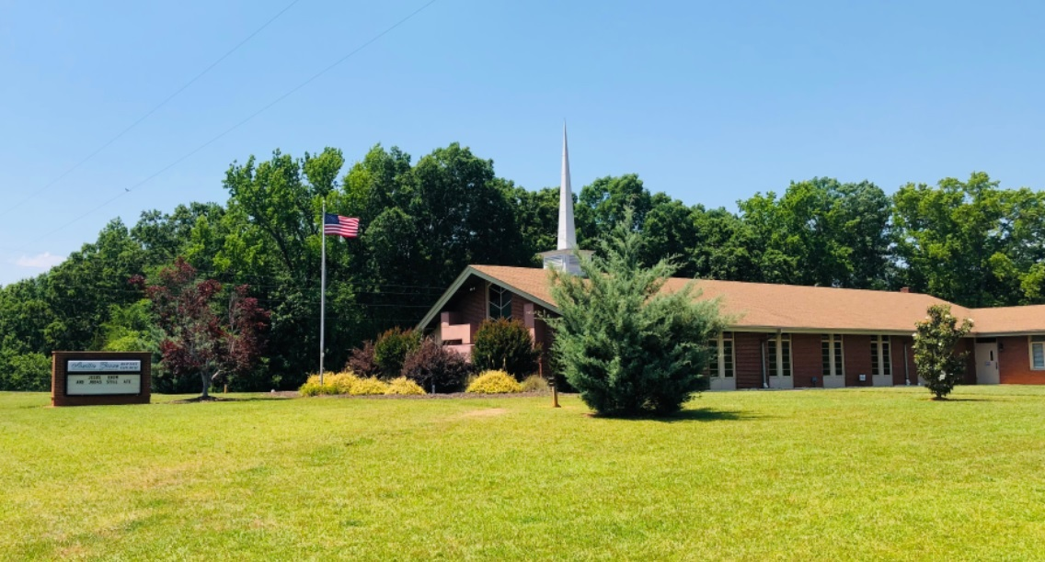
THE ACCENT

AUSTIN GROVE BAPTIST CHURCH
5919 Austin Grove Church Road, Marshville, NC 28103
Website: www.austingrovebaptist.com
E-mail: austingrovebaptist@windstream.net
YouTube Channel: Austin Grove Baptist Church
704-624-2929

October 2022

__________________________________________________________________________________________

To Our Church Family and Friends,

1 John 4:11 Beloved, if God so loved us, we also ought to love one another.
Let me go into the Greek text to give another translation of this verse. “If God so loved us and indeed, He did then we also ought to love one another in the same way”. What a point God is making that He loves us and let’s look at I John 4:10 “He sent His Son into the world to be the atoning sacrifice for our sins.”
Listen to what our Lord is saying “God loved us sacrificially” and if He loves us in such a way we need to make sure that we are also loving one another sacrificially. Love people in the same way God has and continues to love us. What kind of sacrifice does it take to love others? Is it a sacrifice of pride, material things, time, hobbies or even anger?
In the hymn When I Survey the Wondrous Cross, one phrase stands out “Love so amazing, so divine, demands my soul, my life, my all.”
Yes, God does require all of our being, our soul, our life and our all in all. Let me encourage each one to give God your best in everything you do. This is His will and when we live our lives in accordance to His Word, then and only then can God send His blessing our way.
Thanks to each of you for allowing Cindy and me to serve this wonderful congregation.
In Christ,
Leon and Cindy
Sunday, October 23rd
10:45 AM

The October issues of Mature Living and Home Life magazines are on the vestibule table for pick up.

Second Harvest
Wednesday, October 5th
Peachland UMC

Pink Sunday
October 9th
October Fellowship Hall Clean Up:
Prophecy Class

Date Nursery Children’s Church
October 2 | Beverly Napier | Julia & David Godwin
October 9 | Christa & Brandon Love | Teresa Hilton & Gayle Throckmorton
October 16 | Hannah Napier & Hunter Canup | Beverly Napier
October 23 | Debbie Jordan & Amanda Vann | Barbara Simpson & Carolyn Smith
October 30 | Marty Little | Christa & Brandon Love
November 6 | Carter & Laura Dermid | Holly Morris, Katie & Mason Cuthbertson

Mondays from 6:00 – 8:00 PM

Upcoming Youth/Children Events
If questions, call/text Vickie, Janel, Debbie, or Julia.

Wednesday Nights Bible Study 6:45 PM – 7:30 PM

HEARTS ON FIRE 2022
Mini Camp • November 18th – 19th
Pigeon Forge, TN (Details coming.)

Mark your calendars…
THE WORLD OF THE END
January 2023 Book Study
Dr. David Jeremiah

Wednesday, October 26th
6:30 PM Supper; 7:00 PM Costume Contest
7:15 PM Trunk or Treat
In case of rain, come on anyway. There will be a plan

Thursday, October 6th
Bus will leave church at 5:00 PM. Please sign up on bulletin board.
Thank you.

BLANKET PROJECT
In addition to Christmas gifts for needy children in our community, we will also be providing blankets for the elderly. If you would like to donate a blanket to help with this project, please place it in the Welcome Center. We will be collecting them through the first Sunday in December. ?’s-Please see Brenda Walker.

Bells Class Information: We will not have class on any Family Night Meal nights or the last two Wednesdays in October (Family Night Meal and Trunk or Treat).

Bells Class/Practice - Wednesdays 6:00 – 6:30 PM
If any elementary age student wants to take bells (xylophone) COME AND JOIN US. First Songs we will learn: Jesus Loves Me and Morning Has Broken in the key of C.

BIRTHDAYS

HAPPY BIRTHDAY

1 Samuel Viers
2 Christopher Lynn
3 Ava Morris
6 Silar Dermid, Griffin Brazell, Janice James, Carli J. Herring
7 Jeremy Tarleton
9 Jessie Smith Jeffries
10 Jaron Long, Kelly Preslar
12 Doris Edwards
16 Avery Little, Tyler Stewart
17 Tim Simpson
20 Kimberly Rivers
21 Michael Ivey, Tara Throckmorton, Beverly Stewart, Amber Ewing
23 Janet Haigler, Brenda Lee, Asher Gatlin Riggins,
David Wyatt Mullis, Justin Starnes, Gayle Throckmorton, Nancy Riggins
24 Wyatt Griffin, Wyatt Mullis, Sarah Traywick
25 Pat Haigler, Kerstyn Helms, Rachel Viers
28 Brenda Moore
29 Grayson Lynn
30 Autumn Thompson
31 Kim E. Griffin

November 1st Week Birthdays
1 Dustin Marsh, Larry B. Smith, Jr.
4 Donna Ivey
5 Carol Frankenberg, Amanda Jordan Vann
6 Dwight Starnes

Piedmont Community Breast Cancer Walk
October 15th
Registration: 8:00; Walk Begins: 9:00

October
1 Mr. & Mrs. Carter Dermid
2 Mr. & Mrs. Jason Vann
4 Mr. & Mrs. Jacob Collins
7 Mr. & Mrs. Hampton Autry

No November 1st Week

Grandad’s Apples Trip on Monday, October 10th
Hendersonville, NC
We will leave at 8 AM and stop at Biscuitville in Indian Trail for breakfast. We will stop on the way home for a late lunch at Moose Café or Cracker Barrel. Please sign up on the bulletin board if you would like to join us.

Please sign up on the bulletin board if you would like to volunteer or contact the church office if you wish to make a referral to the Christmas Toy Store. Deadline to make a referral is October 12th. Thank you.

Donna Pittman Toy Store
Saturday, December 10th at 8:00 AM

SHOEBOX DEDICATION: Sunday, October 2nd

Samaritan’s Purse Shoebox Packing Night - DATE: TBD
See Melissa Smith for details. Please sign up on the bulletin board if you would like to volunteer.

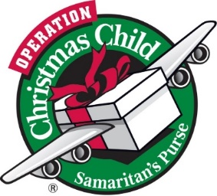

Union County Senior Citizens
24th Annual
Senior Appreciation Day
DATE: October 11, 2022
PLACE: AG Center
TIME: 11 AM – 1 PM
(Doors open at 10 AM)
Reservations required.
Call: 704-292-2613
Reservations close on October 5th.

Our food ministry is increasing drastically as inflation is hurting so many needy families. Marshville Elementary food bags have doubled from 25 to 53! Turning Point has asked for help with a request of 25 bags. This does not include our community families of approximately 30. Money is becoming tight in our ministry, but we don’t want to burden anyone. We have determined a way to give each of you an opportunity to help at very minimal cost! Each Sunday of the month we will ask for a specific item. There will be boxes set out for you to place each item. Below you will find the requests for October. November’s items will be in the November newsletter as well as the bulletins for November. Thank you for any donations for our food ministry. Please see Brenda Walker if you have any questions.
OCTOBER FOOD DONATIONS
1st Sunday…. 15 oz. can of green beans; 2nd Sunday… 15 oz. can of corn
3rd Sunday…. Box of macaroni & cheese(not family size); 4th Sunday…. Box of 12 Ramen noodles
Whether you shop at Food Lion, Aldi, HT, feel free to purchase their store brand.

