The Autumn Care Christmas Angel Party
DATE: Thursday, December 20th
NOTICE TIME CHANGE
TIME: 3:00 PM
PLACE: Autumn Care Chapel
________________________________________________
Celebrating December 5th, 2018 Second Harvest Food Pantry
Thank you to the 27 volunteers who offered a hand! Those served: 122 Families; 6 New Families; 74 children - Ages 18 and Under; 133 adults - Ages 19 to 64; 55 adults - Over 65
Anson Crisis Ministry received 307 lbs. of undistributed drinks and food. Thank you very much!
________________________________________________

You can read all about Emily Oster’s YWAM Missions on her Blog Link at: https://thecalltogo.wordpress.com/
________________________________________________
Our Christmas Play
TONIGHT at 6:00 PM
Today and tonight we will be collecting new and/or gently used shoes and coats for our Souls4Souls Challenge. We will be distributing all items collected through our Shoe and Coat Ministry throughout the school year. Also, ladies please bring finger foods and drinks tonight for fellowship after the play. Thank you.
________________________________________________
December Fellowship Hall Clean-Up:
Knights for Christ, Adult Class #1, Adult Class #5
________________________________________________
If you are able/interested in helping with Sunday Morning Children’s Church and/or Nursery, please let Christa Love know by December 21st. If you are currently helping and want to continue, please let Christa know as well. Thank you.

The Youth Christmas Party that was originally scheduled for today will be rescheduled due to the Christmas Play tonight. Date and time will be announced later. Please see Michael Jordan if you have any questions. Thank you.
________________________________________________
All Christmas Cards Due TODAY.
Please be sure to go by and pick up your cards and also pick up any other family and friend’s cards that you will see this week. Thank you.
________________________________________________
Senior Christmas Party
***NOTICE DATE CHANGE***
DATE/TIME: Wednesday, December 19th at 11:30 AM
PLACE: AGBC Fellowship Hall
Come and enjoy the fun! We will have BINGO and door prizes. You do not need to bring any desserts! Please sign up on the bulletin board. Thank you.
________________________________________________
Thank you to all who help with and gave toys to the
Donna Pittman Toy Store!
________________________________________________
Coming In JANUARY

We will host Second Harvest Food Ministry, Wed., Jan. 2nd (tentative)

Men/Boy’s Meal at Mayfair in Monroe
DATE: Jan 12th TIME: 4:00 PM
We be having a guest speaker,
and would like to invite all men and boys to attend.

UBA Winter Session at Shiloh Baptist Church, January 22nd, 2019

85th Baptist Men’s Day, Sunday, January 27th, 2019

SANCTITY OF HUMAN LIFE – Sunday, January 20, 2019

We will be participating in the Baby Bottle Drive to help raise money for the H.E.L.P. Crisis Pregnancy Center in Monroe.
We will have Baby Bottles available for pick up at a later date.
More details coming soon.

Aus in Grove
Baptist Church

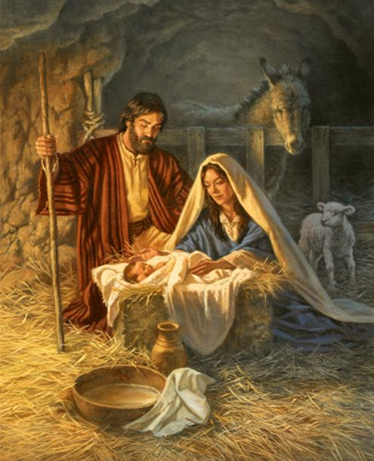

“The Coming Messiah”

5919 Austin Grove Church Road, Marshville, NC 28103
704-624-2929
Website: www.austingrovebaptist.com
E-mail: austingrovebaptist@windstream.net

Rev. Leon Whitley, Pastor ● Home: 704-753-4768
Michael Jordan, Youth Director
Carolyn Smith, Director of Music
Susan Griffin, Pianist
Vickie Griffin & Pat Haigler, Organists

Austin Grove Baptist Church
Sunday, December 16, 2018
____________________________________________________
Call to Worship

Call to Worship Children
“O Come All Ye Faithful and Away In A Manger”

Praise Time
Hymn #91 “Silent Night, Holy Night” Congregation

Welcome, Announcements & Prayer Pastor

Praise Time
Hymn #100 “Angels We Have Heard on High” Congregation

Receiving of Tithes & Offerings/Prayer/Testimony
Offertory Prayer Gene Stewart
Offertory
Offertory Hymn #427 “For He Alone Is Worthy” Congregation

Praise Time
Cantata “The Coming Messiah” Choir

Invitation
Invitation Hymn “Come Just As You Are” Congregation

Benediction Pastor
____________________________________________________

Lottie Moon Goal: $10,642.00
Received: $5,692.00

East Union Washington Trip: $5,971.00
Hurricane Relief: $2,681.48

Children, Youth & Adult Opportunities This Week

SUNDAY
9:45 AM Sunday School
10:45 AM Morning Worship
Please remember to bring finger foods and drinks tonight for fellowship following the play and new and/or gently used shoes & coats for our Souls4Souls Challenge tonight. Thank you.
6:00 PM Christmas Play-Christmas Shoe Tree

MONDAY, WEDNESDAY, FRIDAY
10:00 AM Exercise Class at old Fellowship Hall

TUESDAY
10:00 AM Prayer Meeting & Visitation

WEDNESDAY
11:30 AM *** Senior Christmas Party in the Fellowship Hall***
6:30 PM Student Christmas Celebration
6:45 PM Adult Bible Study
7:30 PM Adult Choir Practice
THURSDAY
3:00 PM Autumn Care Christmas Angel Party in Chapel
NEXT SUNDAY, DECEMBER 23rd No Evening Service
NEXT WEDNESDAY, DECEMBER 26th No services.
____________________________________________________
Nursery
Today: Ray & Heather Smith; Next Week: Janel G. & Emma

Children’s Church (2 year olds through 1st grade)

Today: No Children’s Church today.
The nursery is available if needed.
Next Week: Amanda G. & Dawn M.
____________________________________________________
Greeters
Today: Deb Stewart, Freddy & Rita Griffin, Hampton Autry
Next Week: Joe Little/Hunter, Marty Little, Shirley Griffin
____________________________________________________
Morning Prayer Meeting Follow-Up

Today: Gene Stewart Jimmie & Melva Seay
Next Week: Stephen Walker Freddy & Rita Griffin
Prayer List
Sympathy: Linda Byrum Family,
Anne Cathey Family, Wanda Haigler Family,
Floyd Overcash Family
New: Joyce Boswell, Rowan Carter (Sandra Helms’ Grandson),
Nancy Gales, Kay Haigler, Marty Little, Larry Long,
Gerrie Williams, Unspoken Request
On Going: Marilyn Davis, Carson Guffey,
Andrew Oster, Don James
Those affected by the hurricanes
Kathy Hazelwood, Ron Herr, Garren Janes, Louise James, Ethan Jester Kelcey Jordan, Frances Knight, Richard Langston, Paul Lemmonds, Beverly Martin, Shelia Mazzurco, Kay McBride, William McDaniel, John McManus, William McDaniel Daniel McQuirt, Connie Greene Motley, Judge & Katherine Mullis, William Napier, Andrew Oster & Family, Kathy Overcash, Dean Phifer, Kathy Phifer, Tommy Phillips, Shannon Phifer, Sadie Phillips, Curtis Pittman, Helen Presson, Nancy Riggins, Milo Sligh, Carolyn Smith, Joe Stegall, Debra Stewart, Lucille Stewart, Sarah Stewart, Ben Stoddard , Ashtin Stutts, Gene Stewart, Lucille Stewart, Sarah Traywick, Richard Taylor ,
Maci Wood,
Rev. & Mrs. Leon Whitley,
AGBC, Lost in the Community,
Our Deacons, Our Church Outreach,
Our Service Men & Women,
Leaders of our country,
Jack Austin, Betty Autry,
Dennis Badger, Jr., Lindsay Barmer Delane Bennett, Billy Bennett,
Daniel Broome, Lisa Broome, Phyllis Broome, Tim Broome, Elsie Byrum, Kathryn Byrum, Marie Chaney, Mike Clontz, Ellie Collins, Brannon Crowe, Cecil Deese, Mary Deese, Randy Dyre, Ronald Edwards (Doris), Bill & Carol Fowler, Butch Gilbert, Bobby Griffin, Donald Griffin, Kimberly Griffin, Nancy Grimley, Pat Haigler, Wade Haigler, Debra Hartis, David Logan Hasty,

____________________________________________________
Nursing Homes/Rehabilitation
Brookdale Monroe Square
Mildred Baucom, Room 41

Autumn Care
Ellie Collins, Room 303
Lucy Haney
William Napier, Room 216
Arbor Ridge
Frances Haigler
Arbor Ridge, Apt. 230,
1237 Masten Drive,
Kernersville, NC 27284

Our Missionaries
Wycliffe
Rod & Julie Davis, Isaac, Caleb & Josiah,
Ben Davis; Evan & Carol Smith
________________________________
Emily Oster

Those Serving Our Nation
Leah Gordon, Bryson Griffin, Lydia Griffin, Tyler Griffin, Michael Hagler, Josh Lowery, James Seay, Jacob Smith

